Year 11
Human Biology Excretion/Digestion Test Revision

Which organ in the digestive system creates the following enzymes, and what reactions do they facilitate?

Amylase ____________________________________________________________________________________
Protease ____________________________________________________________________________________
Lipase _____________________________________________________________________________________
Lactase _____________________________________________________________________________________

What is Cellulose useful for in digestion
_____________________________________________________________________________________________

What is the function of bile, and describe its pathway in the digestive process
_____________________________________________________________________________________________
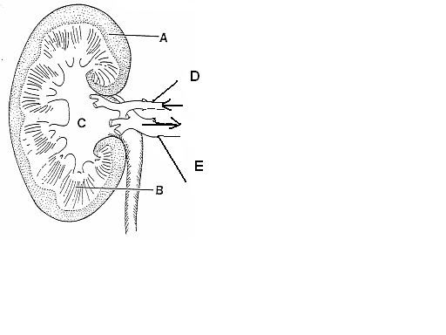
Label parts of the kidney

Name and specify parts of the alimentary canal that: -
absorb nutrients ____________________________________________________________________________
that perform peristalsis _______________________________________________________________________
that perform defecation ______________________________________________________________________

Draw and label parts of a villus and describe where they are found in the digestive system

Describe villus’ function and what makes its physical attributes suitable for its function
___________________________________________________________________________________________
___________________________________________________________________________________________

Describe the role played by each structure in excretion
Lungs _____________________________________________________________________________________
Sweat glands _______________________________________________________________________________
Alimentary canal ____________________________________________________________________________
Kidneys ____________________________________________________________________________________
Liver ______________________________________________________________________________________

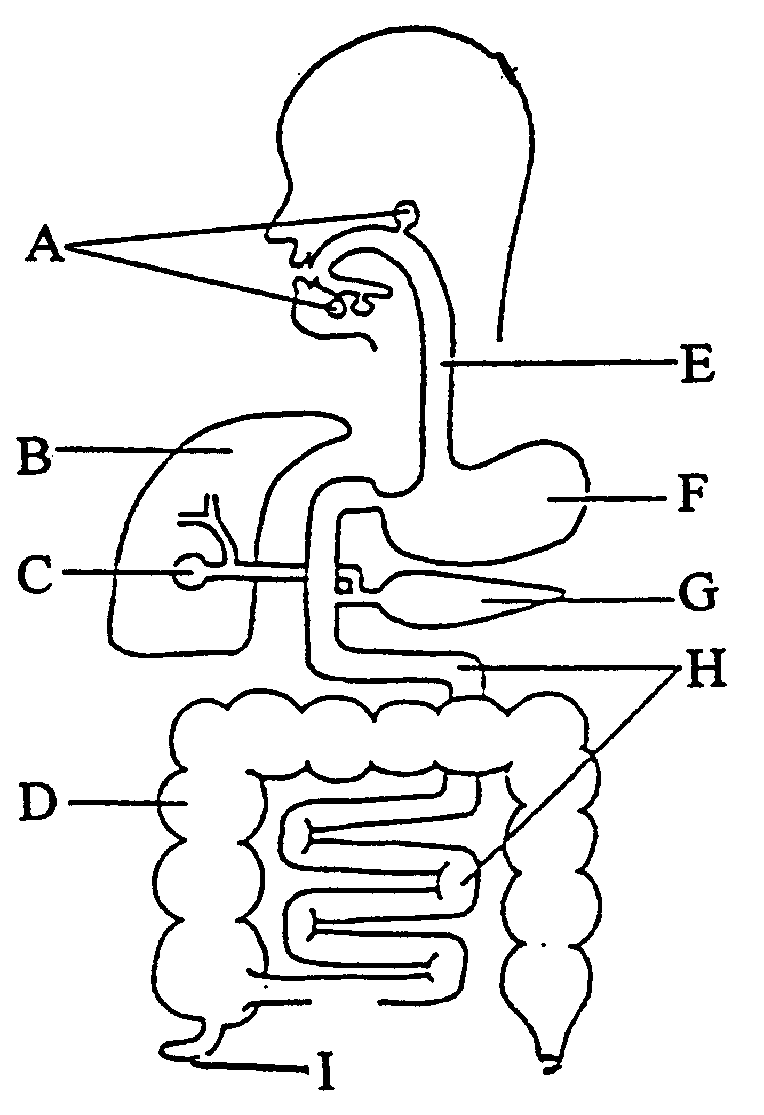
Label the organs of the digestive system

Describe where protein is mostly digested and by what enzyme
_______________________________________________________________________________________________

Define the following terms
Defaecation _____________________________________________________________________________________
Excretion _______________________________________________________________________________________
Elimination _____________________________________________________________________________________
Filtration _______________________________________________________________________________________
Abdominal cavity ________________________________________________________________________________
Cortex _________________________________________________________________________________________
Micturation _____________________________________________________________________________________
Urethra ________________________________________________________________________________________
Ureter _________________________________________________________________________________________
Renal __________________________________________________________________________________________
Urine __________________________________________________________________________________________
Deamination ____________________________________________________________________________________

Compare the contents of the fluids in the renal arteries to the renal veins
_______________________________________________________________________________________________
_______________________________________________________________________________________________
_______________________________________________________________________________________________

Why is ammonia converted to urea? _________________________________________________________________
_______________________________________________________________________________________________
Why is urea excreted? ____________________________________________________________________________
_______________________________________________________________________________________________
What is urine and what substances does it normally contain? _____________________________________________
_______________________________________________________________________________________________
Why are excess proteins deaminated? _______________________________________________________________
_______________________________________________________________________________________________

What is the name of the structure that INITIALLY filters the blood in the kidney? ____________________________
What happens to the urine output if the body fluids contain less water? ___________________________________

Describe why “detox” and “cleanse” fads are a scam ___________________________________________________
______________________________________________________________________________________________
______________________________________________________________________________________________
______________________________________________________________________________________________
______________________________________________________________________________________________

